**PROGRAMS :**

//write a c program to implement linear search

//Ethan Menezes 21co24

#include<stdio.h>

int main()

{

int array[20],size,found=0,number; //variable declaration

printf("Enter the size of array \n"); //accepting size from user

scanf("%d",&size);

printf("Enter the elements \n");

for(int i=0;i<size;i++)

{

scanf("%d",&array[i]); //accepting elements from the user

}

printf("Enter the element to be found \n");

scanf("%d",&number);

for(int i=0;i<size;i++)

{ //logic to find if the umber is present or not

if (number==array[i])

{

printf("found the element %d at location %d",number,i+1);

found=1;

break;

}

}

if(!found)

printf("Element not found\n");

return 0;

}

OUTPUT: Successful:

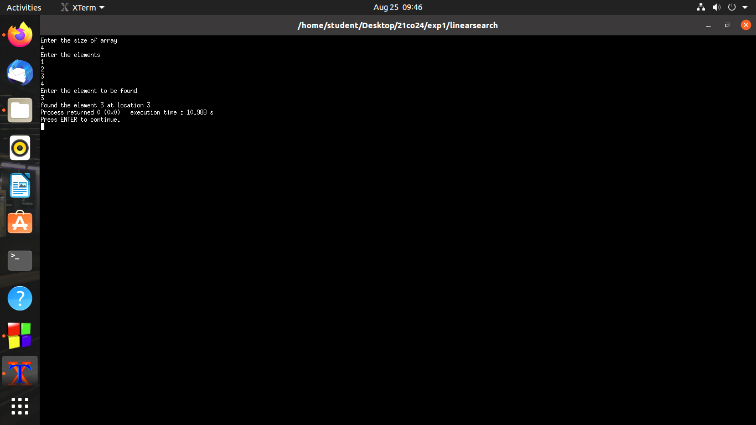

OUTPUT:Unsuccessful

